# CS 255 System Design Document Template

This template lays out all the different sections that you need to complete for Project Two. Each section has guidance to prompt your thinking. You will need to continually reference the interview transcript as you work to make sure that you are addressing your client’s needs. There is no required length for the final document. Instead the goal is to complete each section based on what your client’s needs are. Remove this note when you are finished, and replace all bracketed text with the relevant information.

## UML Diagrams

### UML Use Case Diagram

*[In Module Six, you were asked to complete a use case diagram based on your system design. If you would like to make any adjustments to your diagram, please do so. Please insert your use case diagram here. Check to make sure that you included appropriate components and symbols and that your design meets the client’s needs.]*

### UML Activity Diagrams

*[You were asked to choose* ***two*** *use cases and create* ***two*** *activity diagrams, one for each use case. Please insert* ***both*** *of your activity diagrams here. Check to make sure that you included appropriate components and symbols and that your design meets the client’s needs.]*

**Activity Diagram (1): Login to the System**

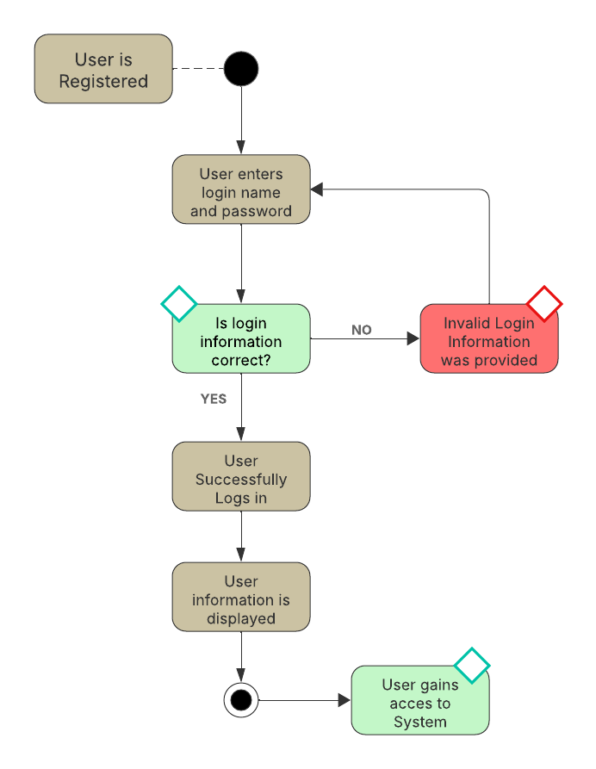

**Activity Diagram (2): Register / Schedule Lessons  
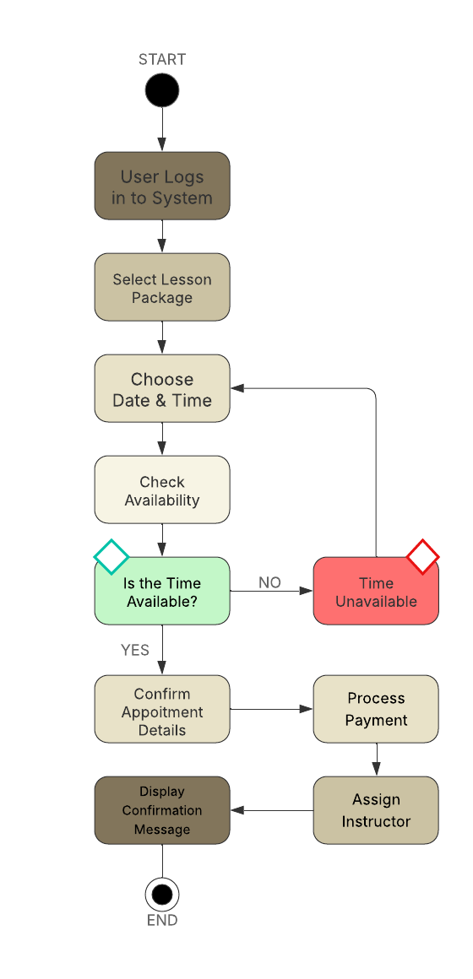**

### UML Sequence Diagram

*[You were asked to create a sequence diagram based on* ***one*** *of the use cases you chose. Please insert your sequence diagram here. Check to make sure that you included appropriate components and symbols and that your design meets the client’s needs.]*

**Login Password Reset:**

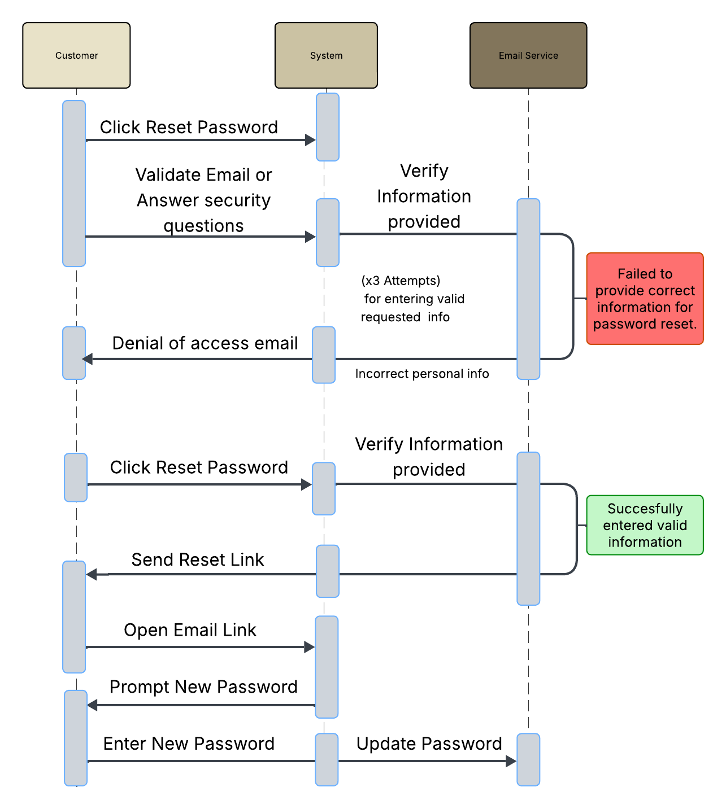

### UML Class Diagram

*[You were asked to create a class diagram based on the different classes and attributes needed for your system design. You are* ***not*** *required to include methods, but you may if you wish. Please insert your class diagram here. Check to make sure that you included appropriate components and symbols and that your design meets the client’s requirements.]  
  
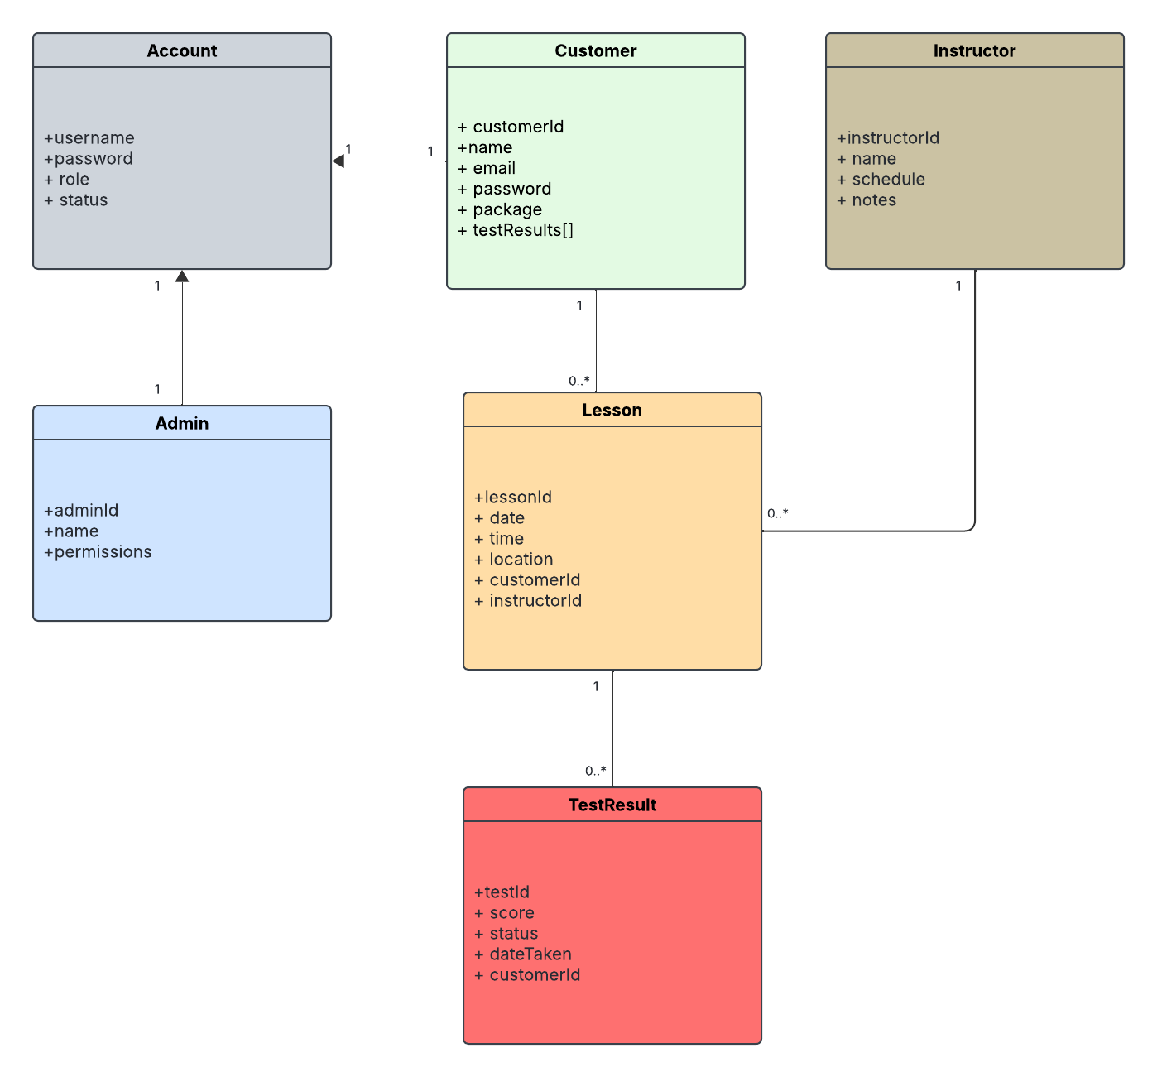*

## Technical Requirements

*[Based on the diagrams you have created, describe the technical requirements of your system. These requirements should address the required hardware, software, tools, and infrastructure necessary for your system design.]*  
Technical Requirements

*To bring the DriverPass system to life, we will need to make sure we are using the right hardware, software, and infrastructure to support both the business and the users. Below is a breakdown of the key technical requirements needed for the system to run smoothly.*

***Hardware Requirements*** *For DriverPass to operate efficiently, basic server infrastructure will be necessary to host the application, database, and user interface. This includes:*

* *A secure web server (e.g., running Linux or Windows Server)*
* *Cloud-based infrastructure or a dedicated server for scalability*
* *Reliable client devices (desktop, tablet, or mobile) with internet access for users and staff*

***Software Requirements*** *The system will be developed as a web-based platform with a responsive frontend and a secure backend. Recommended technologies include:*

* ***Frontend:*** *HTML5, CSS3, JavaScript (React or Angular for a smoother UI)*
* ***Backend:*** *Node.js or Python (Django/Flask) for API logic*
* ***Database:*** *MySQL or PostgreSQL for structured relational data*
* ***Web Server:*** *Apache or NGINX*
* ***Version Control:*** *Git and GitHub for tracking changes*

***Tools and Platforms*** *To support development and collaboration, we will also use:*

* *Lucidchart for designing UML diagrams.*
* *Visual Studio Code (or another IDE)*
* *Trello or Jira for task management (if needed in a real-world setting)*

***Infrastructure and Security*** *Security is a top priority since we are dealing with sensitive user data like login credentials and lesson details. Technical safeguards will include:*

* *HTTPS encryption for all data in transit*
* *Passwords stored using hashed and salted methods.*
* *Role-based access control for admin and instructor accounts*
* *Regular data backups and access logs*
* *Firewall and antivirus protection on servers.*

***Performance and Reliability*** *The system should remain dependable and responsive, even with multiple users logged in at once. To support this, we will need:*

* *Load balancing for handling peak times.*
* *Scalable cloud storage or database solutions*
* *Scheduled maintenance windows for updates*

***User Accessibility*** *To keep DriverPass inclusive and easy to use, the system should:*

* *Support mobile and desktop devices.*
* *Include clear, user-friendly design choices.*
* *Follow accessibility standards (WCAG) where possible.*

*All these requirements are intended to make sure the DriverPass platform is secure, scalable, and user-friendly for students, instructors, and staff.*

***References below.***

***References:***

* *Dennis, A., Wixom, B. H., & Roth, R. M. (2021). Systems analysis and design (7th ed.). Wiley.*
* *Hoffer, J. A., George, J. F., & Valacich, J. S. (2020). Modern systems analysis and design (10th ed.). Pearson.*
* *Kendall, K. E., & Kendall, J. E. (2011). Systems analysis and design (8th ed.). Pearson.*
* *Lucid Software. (n.d.). Create professional diagrams with Lucidchart. Lucidchart.* [*https://www.lucidchart.com*](https://www.lucidchart.com/)
* *National Institute of Standards and Technology. (2022). Framework for improving critical infrastructure*
* *cybersecurity.* [*https://www.nist.gov/cyberframework*](https://www.nist.gov/cyberframework)
* *Microsoft. (2023). Server hardware and software requirements.* [*https://learn.microsoft.com/*](https://learn.microsoft.com/)
* *W3C. (2018). Web content accessibility guidelines (WCAG) 2.1.* [*https://www.w3.org/TR/WCAG21/*](https://www.w3.org/TR/WCAG21/)
* *Lucid Software. (n.d.). Lucidchart tutorials and help center.* [*https://www.lucidchart.com/pages/tutorial*](https://www.lucidchart.com/pages/tutorial)